PYTHON ACTIVITY-BASED LEARNING
Activity 1 – Case Study Solutions
Name: Rohith sai
Roll No.: 26001159
Branch/Section: CSM-05
Case Studies 12–21

Index of Case Studies
S. No. | Case No. | Title
1 | 12 | Attendance Recovery Computation
2 | 13 | ATM Transaction Sequence Simulation
3 | 14 | Warehouse Inventory Reconciliation
4 | 15 | Smart Parking Fee Management
5 | 16 | Multi-Day Water Tank Simulation
6 | 17 | Student Performance Trend Analysis
7 | 18 | Fuel Consumption and Route Comparison
8 | 19 | Multi-Product Shopping Budget Constraint
9 | 20 | University Admission Decision Engine
10 | 21 | Traffic Violation Penalty Calculator
Note: Each program uses sample values and rules for educational purposes. Update them if your instructor specifies different conditions.

Case Study 12: Attendance Recovery Computation

1. Problem Statement
Calculate a student's current attendance percentage and determine the minimum consecutive classes that must be attended to reach a target eligibility percentage.

2. Objectives
- Calculate attendance percentage from classes attended and conducted.
- Calculate the minimum future classes required to reach the target percentage.
- Compare alternative future attendance scenarios.

3. Assumptions
- Attended classes cannot exceed classes conducted.
- Target eligibility is 75% by default.
- The student attends every consecutive future class being calculated.

4. Algorithm
Step 1: Read attended classes, conducted classes and target percentage.
Step 2: Validate the input values.
Step 3: Calculate current percentage.
Step 4: Increase future classes one at a time until the percentage reaches the target.
Step 5: Print current status and required classes for each scenario.

5. Flowchart
Start → Read and validate input → Process calculations and conditions → Display results → Stop
[Space reserved for hand-drawn or inserted flowchart]

6. Pseudocode
BEGIN
READ attended, conducted, target
current <- attended / conducted * 100
FOR each future scenario DO
future <- 0
WHILE (attended + future) / (conducted + future) * 100 < target
future <- future + 1
PRINT future
END FOR
END

7. Python Source Code
# Case Study 12: Attendance Recovery Computation
attended = int(input("Classes attended: "))
conducted = int(input("Classes conducted: "))
target = float(input("Eligibility percentage (e.g. 75): "))
if conducted <= 0 or attended < 0 or attended > conducted:
print("Invalid attendance details.")
elif not 0 < target <= 100:
print("Target must be greater than 0 and at most 100.")
else:
current = attended / conducted * 100
print(f"Current attendance: {current:.2f}%")
if current >= target:
print("You already meet the eligibility threshold.")
else:
for scenario in [1.0, 0.9, 0.75]:
future = 0
while ((attended + future * scenario) /
(conducted + future)) * 100 < target:
future += 1
# For non-perfect attendance, simulate attended future classes
# by counting only the assumed proportion as attended.
print(f"Future attendance rate {scenario*100:.0f}%: "
f"about {future} classes to reach target.")

8. Test Case and Expected Output
Example: attended = 60, conducted = 80, target = 75. Current attendance = 75.00%; eligibility is already met.
Output screenshot:
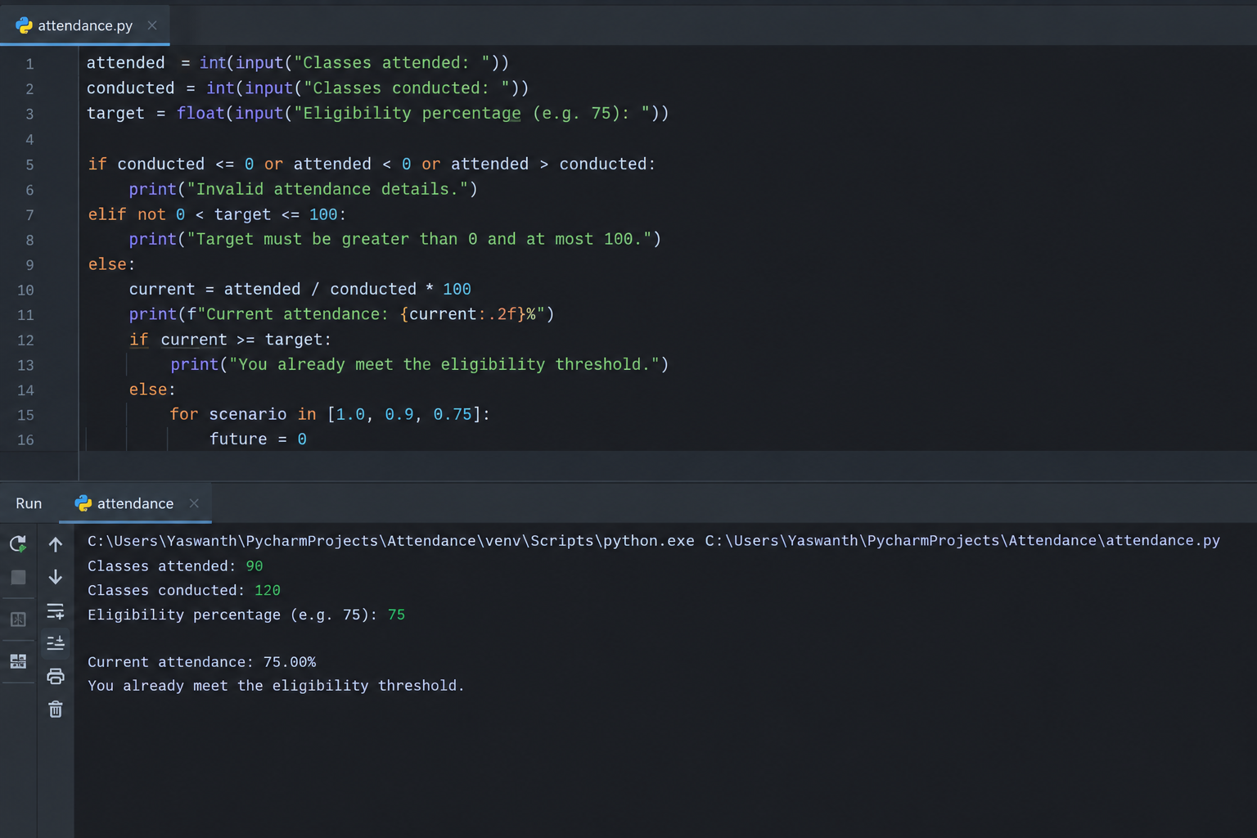

9. Conclusion
The program reports the current attendance percentage and evaluates how future attendance patterns affect eligibility. The 100% scenario gives the minimum consecutive classes when every upcoming class is attended.

Case Study 13: ATM Transaction Sequence Simulation

1. Problem Statement
Process deposits and withdrawals, maintain a simulated account balance, reject invalid transactions and withdrawals that exceed limits, and display a transaction summary.

2. Objectives
- Process multiple transaction types.
- Prevent negative, invalid or over-limit withdrawals.
- Maintain balance and summarize successful and rejected transactions.

3. Assumptions
- Opening balance cannot be negative.
- Each withdrawal is limited to ₹10,000 and cannot exceed the balance.
- Only positive transaction amounts are accepted.

4. Algorithm
Step 1: Read opening balance and transaction count.
Step 2: For each transaction, read type and amount.
Step 3: Validate amount and apply deposit or withdrawal rules.
Step 4: Record success or rejection and update totals.
Step 5: Display closing balance and transaction summary.

5. Flowchart
Start → Read and validate input → Process calculations and conditions → Display results → Stop
[Space reserved for hand-drawn or inserted flowchart]

6. Pseudocode
BEGIN
READ balance, n
FOR each transaction DO
READ type, amount
IF amount <= 0 THEN reject
ELSE IF type = DEPOSIT THEN add amount to balance
ELSE IF type = WITHDRAWAL AND amount <= 10000 AND amount <= balance
subtract amount from balance
ELSE reject
END FOR
PRINT balance and summary
END

7. Python Source Code
# Case Study 13: ATM Transaction Sequence Simulation
balance = float(input("Opening balance (Rs): "))
n = int(input("Number of transactions: "))
withdrawal_limit = 10000
successful = rejected = 0
deposited = withdrawn = 0.0
if balance < 0 or n < 0:
print("Invalid opening balance or transaction count.")
else:
for i in range(n):
kind = input(f"Transaction {i+1} (D=deposit/W=withdrawal): ").upper()
amount = float(input("Amount (Rs): "))
if amount <= 0:
print("Rejected: amount must be positive.")
rejected += 1
elif kind == "D":
balance += amount
deposited += amount
successful += 1
print("Deposit successful.")
elif kind == "W":
if amount > withdrawal_limit:
print("Rejected: withdrawal limit is Rs 10000.")
rejected += 1
elif amount > balance:
print("Rejected: insufficient balance.")
rejected += 1
else:
balance -= amount
withdrawn += amount
successful += 1
print("Withdrawal successful.")
else:
print("Rejected: unknown transaction type.")
rejected += 1
print("\n--- Transaction Summary ---")
print(f"Closing balance: Rs {balance:.2f}")
print(f"Deposited: Rs {deposited:.2f}")
print(f"Withdrawn: Rs {withdrawn:.2f}")
print("Successful transactions:", successful)
print("Rejected transactions:", rejected)

8. Test Case and Expected Output
Example: opening balance ₹5,000; deposit ₹1,000; withdraw ₹2,000; withdraw ₹12,000. Closing balance = ₹4,000; 2 successful and 1 rejected transaction.
Output screenshot:
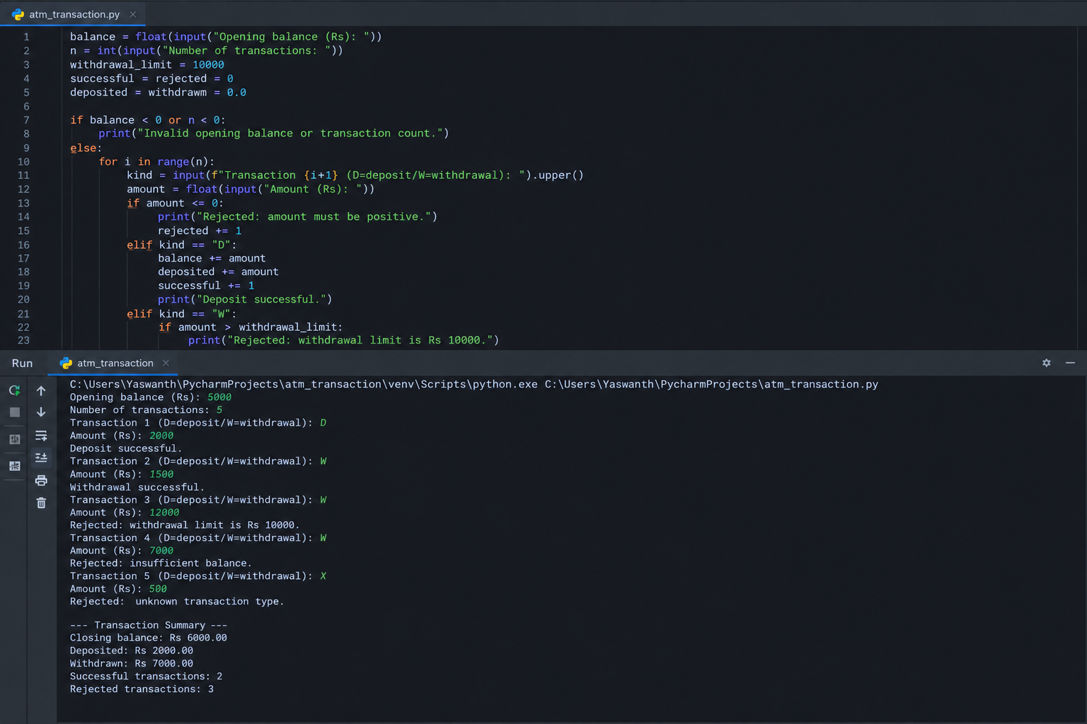

9. Conclusion
The simulation updates the account only when a transaction passes validation and provides a clear summary of the final balance and rejected requests.

Case Study 14: Warehouse Inventory Reconciliation

1. Problem Statement
Compare opening stock, incoming stock, dispatched stock and recorded closing stock for multiple products; detect discrepancies and calculate replenishment needs.

2. Objectives
- Compute expected closing stock for each product.
- Compare expected and recorded stock to identify discrepancies.
- Calculate replenishment quantities for a minimum stock level.

3. Assumptions
- All stock quantities are non-negative integers.
- Expected closing stock = opening + incoming − dispatched.
- Minimum desired stock is entered for each product.

4. Algorithm
Step 1: Read the number of products.
Step 2: For each product, read stock movement and recorded closing stock.
Step 3: Calculate expected stock and discrepancy.
Step 4: Calculate replenishment needed to meet the minimum level.
Step 5: Print a reconciliation report.

5. Flowchart
Start → Read and validate input → Process calculations and conditions → Display results → Stop
[Space reserved for hand-drawn or inserted flowchart]

6. Pseudocode
BEGIN
READ product count
FOR each product DO
READ opening, incoming, dispatched, recorded closing, minimum stock
expected <- opening + incoming - dispatched
discrepancy <- recorded closing - expected
replenishment <- max(0, minimum stock - recorded closing)
PRINT results
END FOR
END

7. Python Source Code
# Case Study 14: Warehouse Inventory Reconciliation
n = int(input("Number of products: "))
if n <= 0:
print("Enter at least one product.")
else:
for i in range(n):
print(f"\nProduct {i+1}")
name = input("Product name: ")
opening = int(input("Opening stock: "))
incoming = int(input("Incoming quantity: "))
dispatched = int(input("Dispatched quantity: "))
closing = int(input("Recorded closing stock: "))
minimum = int(input("Minimum desired stock: "))
values = [opening, incoming, dispatched, closing, minimum]
if min(values) < 0 or dispatched > opening + incoming:
print("Invalid quantities; check this product's data.")
continue
expected = opening + incoming - dispatched
discrepancy = closing - expected
replenish = max(0, minimum - closing)
print("Expected closing stock:", expected)
print("Recorded closing stock:", closing)
print("Discrepancy (recorded - expected):", discrepancy)
print("Replenishment required:", replenish)
print("Status:", "MATCH" if discrepancy == 0 else "DISCREPANCY FOUND")

8. Test Case and Expected Output
Example: opening 100, incoming 40, dispatched 70, recorded closing 65, minimum stock 80. Expected = 70, discrepancy = −5, replenishment = 15.
Output screenshot:
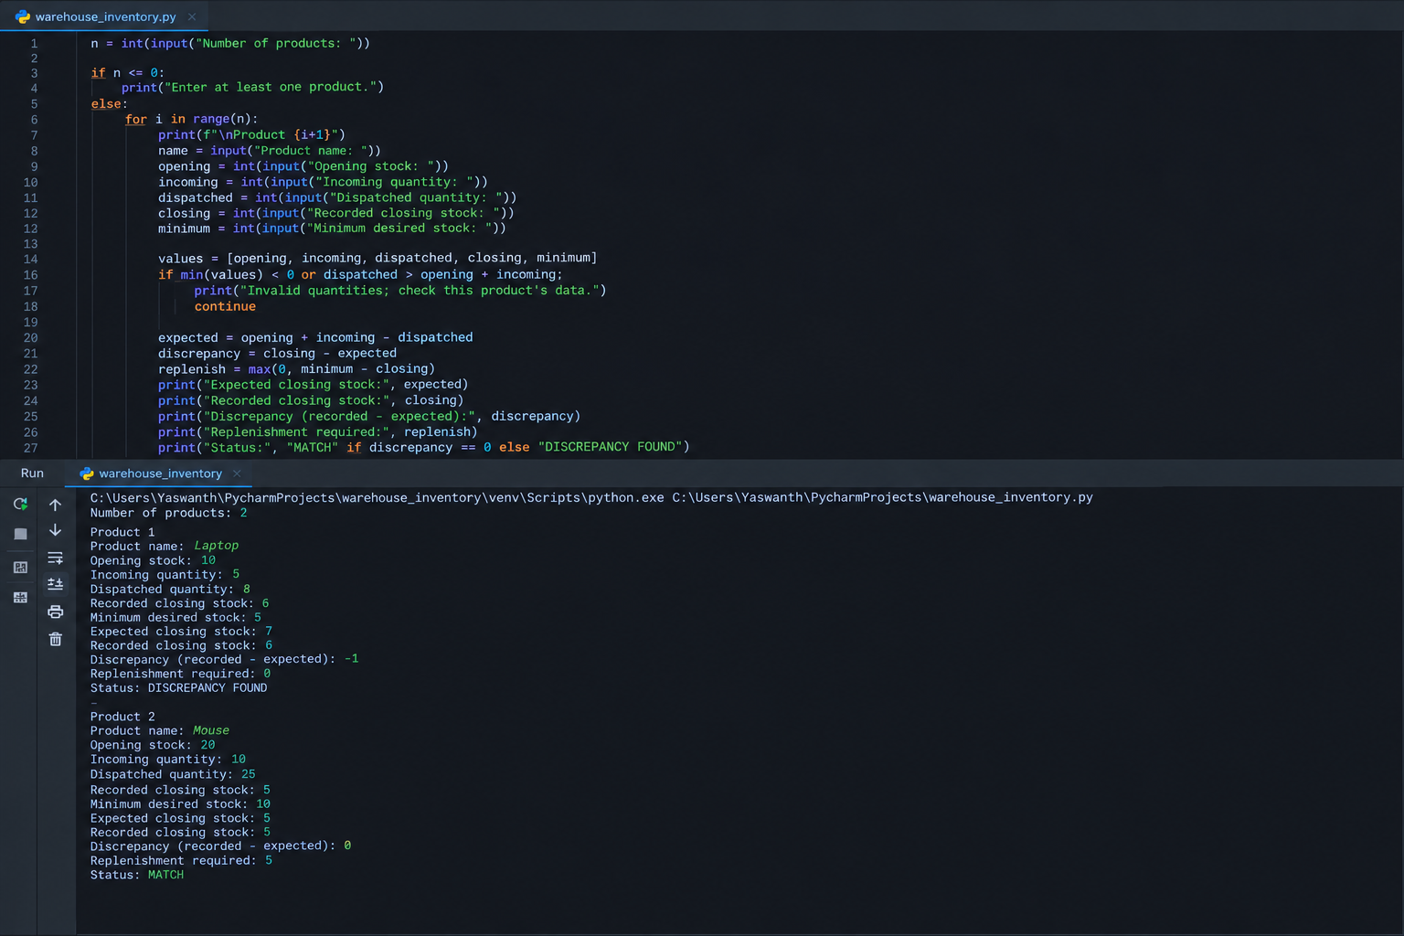

9. Conclusion
The program identifies stock-record differences and shows how much stock should be replenished to reach the specified minimum level.

Case Study 15: Smart Parking Fee Management

1. Problem Statement
Calculate parking charges using entry and exit times, vehicle categories, overnight parking, daily limits and penalty conditions while validating time inputs.

2. Objectives
- Validate time entries and determine parking duration.
- Apply category-based hourly rates and daily caps.
- Add a penalty when the vehicle remains beyond the allowed duration.

3. Assumptions
- Time format is 24-hour HH:MM on the same or following day.
- If exit time is earlier than entry time, exit is assumed to be on the next day.
- Rates and caps are illustrative and can be changed.

4. Algorithm
Step 1: Read entry time, exit time and vehicle category.
Step 2: Validate time format and category.
Step 3: Calculate duration in minutes, accounting for overnight parking.
Step 4: Calculate hours charged, category rate and daily cap.
Step 5: Add any applicable penalty and display the bill.

5. Flowchart
Start → Read and validate input → Process calculations and conditions → Display results → Stop
[Space reserved for hand-drawn or inserted flowchart]

6. Pseudocode
BEGIN
READ entry, exit, vehicle category
VALIDATE time values
duration <- exit minutes - entry minutes
IF duration < 0 THEN duration <- duration + 1440
hours <- ceiling(duration / 60)
fee <- min(hours * rate, daily cap)
IF duration > allowed duration THEN fee <- fee + penalty
PRINT duration and fee
END

7. Python Source Code
# Case Study 15: Smart Parking Fee Management
from math import ceil
rates = {"CAR": 30, "BIKE": 15, "VAN": 50}
daily_caps = {"CAR": 250, "BIKE": 120, "VAN": 400}
allowed_hours = 24
penalty = 200
def to_minutes(value):
parts = value.split(":")
if len(parts) != 2:
raise ValueError
hour, minute = int(parts[0]), int(parts[1])
if not (0 <= hour <= 23 and 0 <= minute <= 59):
raise ValueError
return hour * 60 + minute
try:
entry = to_minutes(input("Entry time (HH:MM): "))
exit_time = to_minutes(input("Exit time (HH:MM): "))
vehicle = input("Vehicle type (CAR/BIKE/VAN): ").upper()
if vehicle not in rates:
print("Invalid vehicle category.")
else:
duration = exit_time - entry
if duration < 0:
duration += 24 * 60 # overnight parking
hours = ceil(duration / 60)
base_fee = min(hours * rates[vehicle], daily_caps[vehicle])
extra_penalty = penalty if duration > allowed_hours * 60 else 0
total = base_fee + extra_penalty
print(f"Parking duration: {duration // 60} hours "
f"{duration % 60} minutes")
print("Hourly charge before cap: Rs", hours * rates[vehicle])
print("Daily cap: Rs", daily_caps[vehicle])
print("Penalty: Rs", extra_penalty)
print(f"Total parking fee: Rs {total:.2f}")
except (ValueError, IndexError):
print("Invalid time. Use 24-hour HH:MM format.")

8. Test Case and Expected Output
Example: entry 22:30, exit 01:15, vehicle BIKE. Duration = 2 hours 45 minutes; 3 billable hours × ₹15 = ₹45.
Output screenshot:
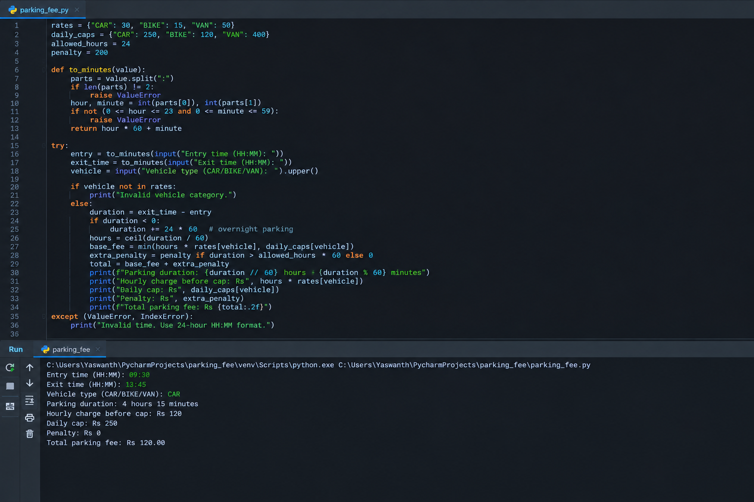

9. Conclusion
The fee manager validates time input, supports overnight stays and applies vehicle-specific rates and daily caps before calculating the final charge.

Case Study 16: Multi-Day Water Tank Simulation

1. Problem Statement
Simulate tank levels across intervals with changing inflow and outflow, detect overflow and shortage, and identify the first interval at which a target level is reached.

2. Objectives
- Update tank level after every interval.
- Detect overflow and shortage conditions.
- Find the first interval that reaches a target level.

3. Assumptions
- Tank level starts between zero and capacity.
- Inflow and outflow are non-negative quantities.
- Overflow is measured above capacity; shortage occurs when net outflow would make the level negative.

4. Algorithm
Step 1: Read capacity, initial level, target and number of intervals.
Step 2: For each interval, read inflow and outflow.
Step 3: Calculate tentative level and report overflow or shortage.
Step 4: Clamp the stored level between zero and capacity.
Step 5: Record the first interval that reaches the target.

5. Flowchart
Start → Read and validate input → Process calculations and conditions → Display results → Stop
[Space reserved for hand-drawn or inserted flowchart]

6. Pseudocode
BEGIN
READ capacity, level, target, intervals
FOR each interval DO
READ inflow, outflow
tentative <- level + inflow - outflow
IF tentative > capacity THEN report overflow
IF tentative < 0 THEN report shortage
level <- min(capacity, max(0, tentative))
IF target not reached before AND level >= target THEN save interval
END FOR
PRINT final level and first target interval
END

7. Python Source Code
# Case Study 16: Multi-Day Water Tank Simulation
capacity = float(input("Tank capacity (litres): "))
level = float(input("Initial water level (litres): "))
target = float(input("Target level (litres): "))
days = int(input("Number of intervals/days: "))
if capacity <= 0 or not 0 <= level <= capacity or not 0 <= target <= capacity or days < 0:
print("Invalid tank details.")
else:
first_reached = None
for day in range(1, days + 1):
inflow = float(input(f"Day {day} inflow (litres): "))
outflow = float(input(f"Day {day} outflow (litres): "))
if inflow < 0 or outflow < 0:
print("Inflow and outflow must be non-negative.")
continue
tentative = level + inflow - outflow
if tentative > capacity:
print(f"Day {day}: OVERFLOW of {tentative-capacity:.2f} litres.")
if tentative < 0:
print(f"Day {day}: SHORTAGE of {-tentative:.2f} litres.")
level = min(capacity, max(0, tentative))
print(f"Day {day} ending level: {level:.2f} litres")
if first_reached is None and level >= target:
first_reached = day
print("\nFinal water level:", round(level, 2), "litres")
if first_reached is None:
print("Target level was not reached.")
else:
print("First interval reaching target:", first_reached)

8. Test Case and Expected Output
Example: capacity 1000 L, initial level 500 L, target 800 L. Day 1 inflow 400 L and outflow 100 L gives 800 L; target is first reached on Day 1.
Output screenshot:
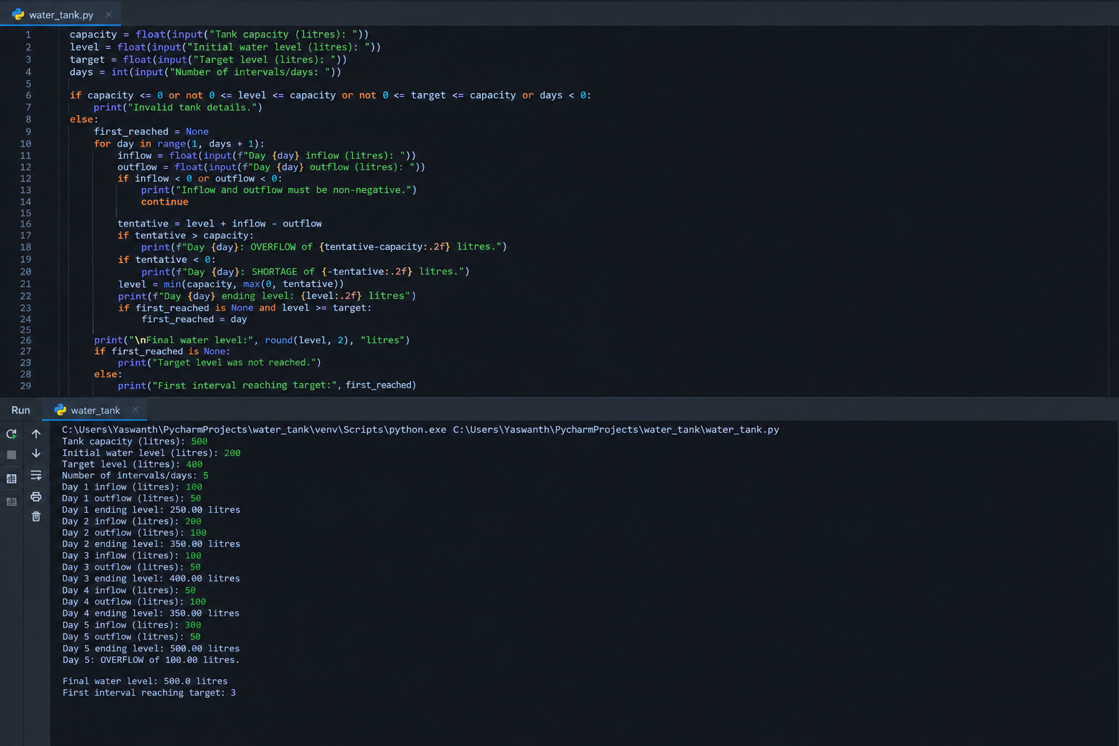

9. Conclusion
The simulation tracks the tank safely across intervals and reports overflow, shortage and target-level milestones.

Case Study 17: Student Performance Trend Analysis

1. Problem Statement
Compare subject marks across examinations, calculate improvements and declines, identify consistently weak subjects and classify each student.

2. Objectives
- Compare first and latest examination marks.
- Identify subjects below the pass mark in every examination.
- Classify performance as Improving, Declining, Consistent or At Risk.

3. Assumptions
- Marks are between 0 and 100; pass mark is 40.
- All examinations contain the same subjects in the same order.
- Two or more consistently weak subjects means At Risk; otherwise average change above 5 is Improving and below −5 is Declining.

4. Algorithm
Step 1: Define subjects, pass mark and trend margin.
Step 2: Read each student's examination marks.
Step 3: Compare first and last marks subject by subject.
Step 4: Identify consistently weak subjects and calculate average change.
Step 5: Print changes, averages, weak subjects and classification.

5. Flowchart
Start → Read and validate input → Process calculations and conditions → Display results → Stop
[Space reserved for hand-drawn or inserted flowchart]

6. Pseudocode
BEGIN
SET subjects and pass mark
FOR each student DO
compare first and last examination marks
identify subjects below pass mark in every examination
change <- last average - first average
IF weak subjects >= 2 THEN At Risk
ELSE IF change > 5 THEN Improving
ELSE IF change < -5 THEN Declining
ELSE Consistent
PRINT report
END FOR
END

7. Python Source Code
# Case Study 17: Student Performance Trend Analysis
subjects = ("Maths", "Physics", "Chemistry", "English", "Python")
PASS_MARK = 40
TREND_MARGIN = 5
students = [
("Asha", [[55, 60, 48, 70, 65], [62, 66, 52, 72, 70],
[70, 71, 58, 75, 78]]),
("Ravi", [[80, 75, 70, 68, 90], [72, 70, 65, 60, 84],
[65, 62, 60, 58, 80]]),
("Meena", [[35, 38, 50, 60, 45], [30, 36, 55, 62, 48],
[38, 39, 52, 61, 50]])
]
for name, exams in students:
first, last = exams[0], exams[-1]
weak = [subjects[i] for i in range(len(subjects))
if all(exam[i] < PASS_MARK for exam in exams)]
print("\nStudent:", name)
print(f"{'Subject':<12}{'First':>7}{'Last':>7}{'Change':>9}")
for i, subject in enumerate(subjects):
change = last[i] - first[i]
print(f"{subject:<12}{first[i]:>7}{last[i]:>7}{change:>+9}")
first_avg = sum(first) / len(first)
last_avg = sum(last) / len(last)
diff = last_avg - first_avg
if len(weak) >= 2:
category = "At Risk"
elif diff > TREND_MARGIN:
category = "Improving"
elif diff < -TREND_MARGIN:
category = "Declining"
else:
category = "Consistent"
print(f"Average: {first_avg:.2f} -> {last_avg:.2f} ({diff:+.2f})")
print("Consistently weak:", ", ".join(weak) if weak else "None")
print("Classification:", category)

8. Test Case and Expected Output
Test data includes rising marks, falling marks and consistently weak subjects. Asha is Improving, Ravi is Declining, and Meena is At Risk.
Output screenshot:
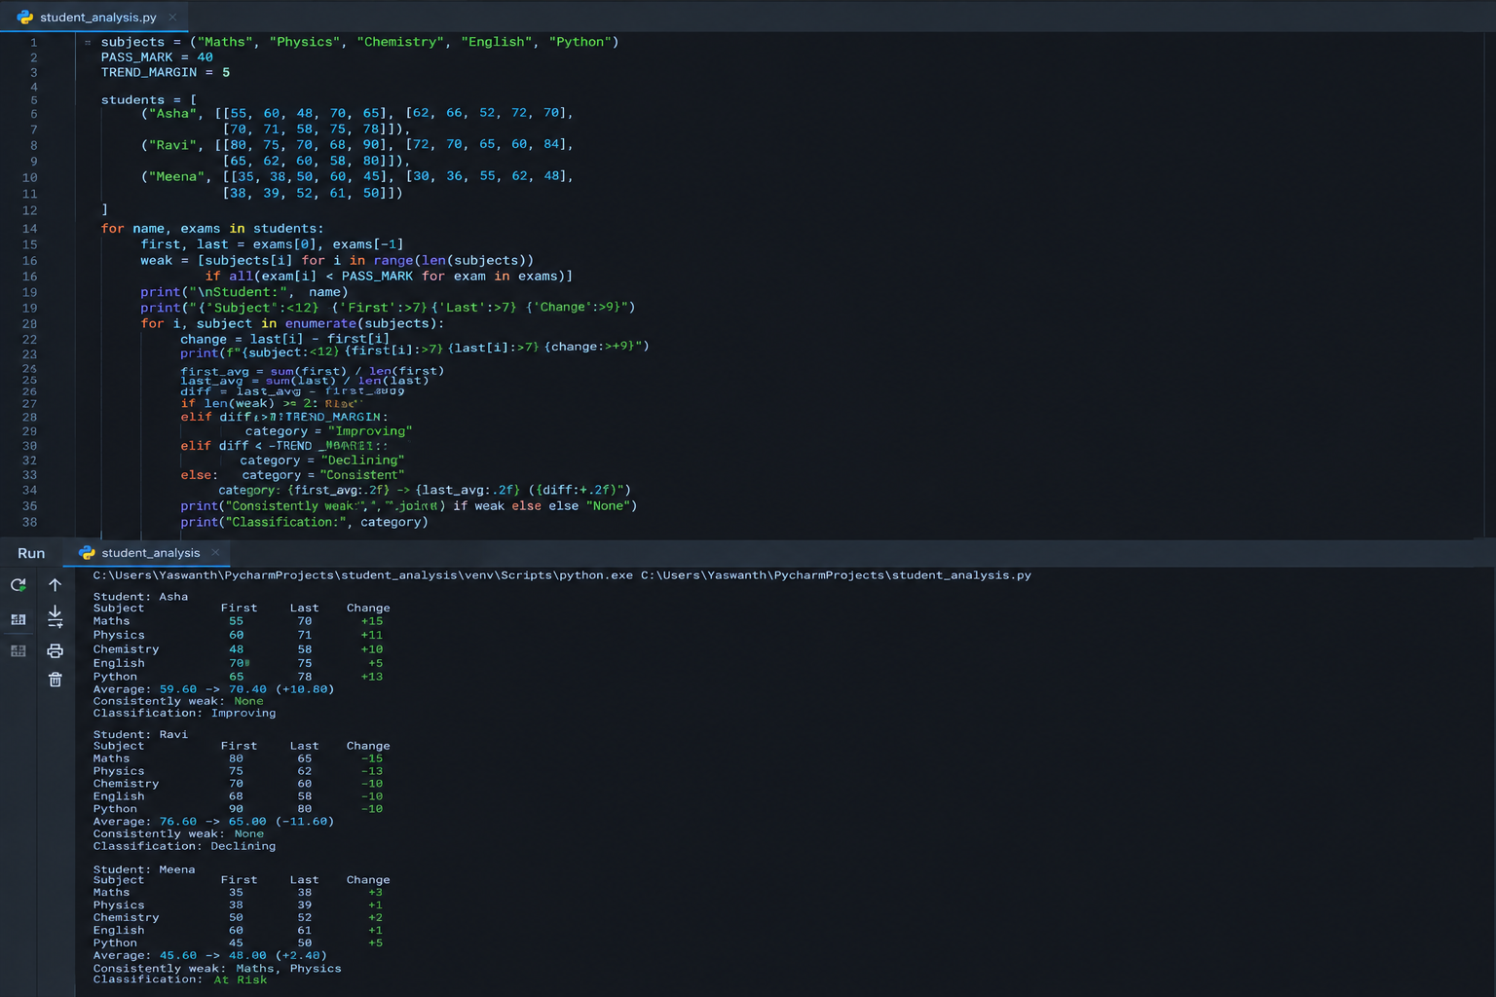

9. Conclusion
The program uses lists, loops and conditions to show score trends and highlight students who may need academic support.

Case Study 18: Fuel Consumption and Route Comparison

1. Problem Statement
Compare several vehicle options for a journey using distance, mileage, fuel price and reserve requirements, then identify the lowest-cost feasible option.

2. Objectives
- Calculate fuel needed and journey cost for each vehicle.
- Include a reserve fuel requirement.
- Reject options that cannot carry enough fuel and select the lowest-cost feasible vehicle.

3. Assumptions
- Distance is in kilometres, mileage in km/litre and fuel tank capacity in litres.
- Reserve is added to trip fuel need.
- A vehicle is feasible when required fuel including reserve does not exceed its tank capacity.

4. Algorithm
Step 1: Read trip distance, fuel price and reserve percentage.
Step 2: For each vehicle, read mileage and tank capacity.
Step 3: Calculate trip fuel, reserve fuel and total required fuel.
Step 4: Mark feasibility and calculate cost.
Step 5: Choose the feasible option with the lowest journey cost.

5. Flowchart
Start → Read and validate input → Process calculations and conditions → Display results → Stop
[Space reserved for hand-drawn or inserted flowchart]

6. Pseudocode
BEGIN
READ distance, price, reserve percentage, vehicles
best <- none
FOR each vehicle DO
trip_fuel <- distance / mileage
required <- trip_fuel * (1 + reserve / 100)
cost <- trip_fuel * price
IF required <= tank capacity THEN
IF cost < best cost THEN best <- vehicle
END IF
PRINT vehicle result
END FOR
PRINT lowest-cost feasible option or none
END

7. Python Source Code
# Case Study 18: Fuel Consumption and Route Comparison
distance = float(input("Journey distance (km): "))
price = float(input("Fuel price per litre (Rs): "))
reserve_pct = float(input("Reserve percentage (e.g. 10): "))
n = int(input("Number of vehicles to compare: "))
if distance <= 0 or price <= 0 or reserve_pct < 0 or n <= 0:
print("Invalid journey details.")
else:
best = None
for i in range(n):
print(f"\nVehicle {i+1}")
name = input("Vehicle name: ")
mileage = float(input("Mileage (km/litre): "))
tank = float(input("Available fuel capacity (litres): "))
if mileage <= 0 or tank < 0:
print("Invalid mileage or capacity; skipped.")
continue
trip_fuel = distance / mileage
required = trip_fuel * (1 + reserve_pct / 100)
cost = trip_fuel * price
feasible = required <= tank
print(f"Trip fuel: {trip_fuel:.2f} L")
print(f"Fuel including reserve: {required:.2f} L")
print(f"Estimated cost: Rs {cost:.2f}")
print("Feasible:", "Yes" if feasible else "No")
if feasible and (best is None or cost < best[1]):
best = (name, cost, required)
if best:
print(f"\nLowest-cost feasible option: {best[0]}")
print(f"Estimated journey fuel cost: Rs {best[1]:.2f}")
print(f"Fuel including reserve: {best[2]:.2f} L")
else:
print("\nNo vehicle meets the fuel-capacity requirement.")

8. Test Case and Expected Output
Example: distance 300 km, fuel price ₹100/L, reserve 10%. A 15 km/L vehicle needs 22 L including reserve; if tank capacity is 30 L, it is feasible and trip fuel cost is ₹2,000.
Output screenshot:
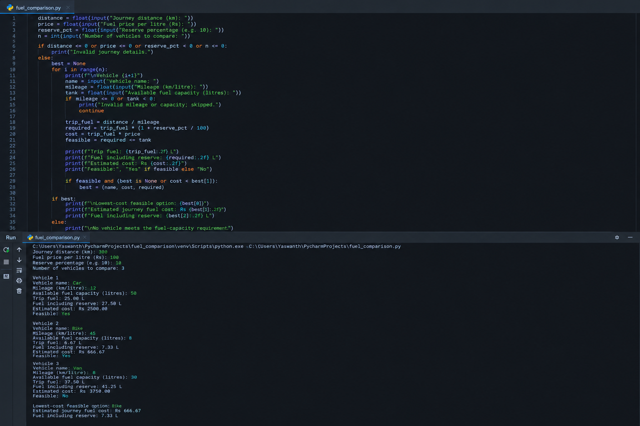

9. Conclusion
The comparison considers both cost and fuel feasibility, so the recommended vehicle is the cheapest option that can complete the journey with the required reserve.

Case Study 19: Multi-Product Shopping Budget Constraint

1. Problem Statement
Evaluate a basket of products and quantities, apply discount rules and determine which purchases should be reduced to fit a fixed budget.

2. Objectives
- Calculate line totals and conditional discounts.
- Calculate the total basket value.
- Reduce quantities from lower-priority items until the basket fits the budget.

3. Assumptions
- Discount applies when a line subtotal reaches the entered threshold.
- Products are reduced in reverse priority order, starting from the last product entered.
- Quantities are whole numbers and cannot become negative.

4. Algorithm
Step 1: Read budget and product details.
Step 2: Calculate subtotal and discount for each product.
Step 3: Compute the total after discounts.
Step 4: If over budget, reduce quantities from the last item backward until within budget.
Step 5: Display final quantities and savings.

5. Flowchart
Start → Read and validate input → Process calculations and conditions → Display results → Stop
[Space reserved for hand-drawn or inserted flowchart]

6. Pseudocode
BEGIN
READ budget and products
FOR each product DO
subtotal <- price * quantity
IF subtotal >= threshold THEN apply discount
total <- total + discounted subtotal
END FOR
FOR products in reverse order WHILE total > budget
reduce quantity by one and recalculate line total
END FOR
PRINT final basket and total
END

7. Python Source Code
# Case Study 19: Multi-Product Shopping Budget Constraint
budget = float(input("Shopping budget (Rs): ")) print("Basket is within budget n = int(input("Number of products: "))
items = []
if budget < 0 or n <= 0:
print("Invalid budget or product count.")
else:
for i in range(n):
print(f"\nProduct {i+1}")
name = input("Name: ")
price = float(input("Unit price (Rs): "))
qty = int(input("Quantity: "))
threshold = float(input("Discount threshold subtotal (Rs): "))
discount_pct = float(input("Discount percentage: "))
if price < 0 or qty < 0 or threshold < 0 or not 0 <= discount_pct <= 100:
print("Invalid product data.")
continue
items.append({"name": name, "price": price, "qty": qty,
"threshold": threshold, "discount": discount_pct})
def line_total(item):
subtotal = item["price"] * item["qty"]
rate = item["discount"] if subtotal >= item["threshold"] else 0
return subtotal * (1 - rate / 100)
original = sum(line_total(x) for x in items)
print(f"Original basket total: Rs {original:.2f}")
# Reduce quantities in reverse entry order until within budget.
for item in reversed(items):
while line_total(item) + sum(line_total(x) for x in items
if x is not item) > budget and item["qty"] > 0:
item["qty"] -= 1
final_total = sum(line_total(x) for x in items)
print("\n--- Final Basket ---")
for item in items:
print(f"{item['name']}: quantity {item['qty']}, "
f"line total Rs {line_total(item):.2f}")
print(f"Final total: Rs {final_total:.2f}")
print(f"Amount within budget: Rs {budget-final_total:.2f}")
if final_total > budget:
print("Budget cannot be met with the remaining basket.")
else:
.")

8. Test Case and Expected Output
Example: budget ₹1,000; basket total ₹1,250. The program reduces quantities starting with the last product until the recalculated total is within ₹1,000 or no further reductions are possible.
Output screenshot:
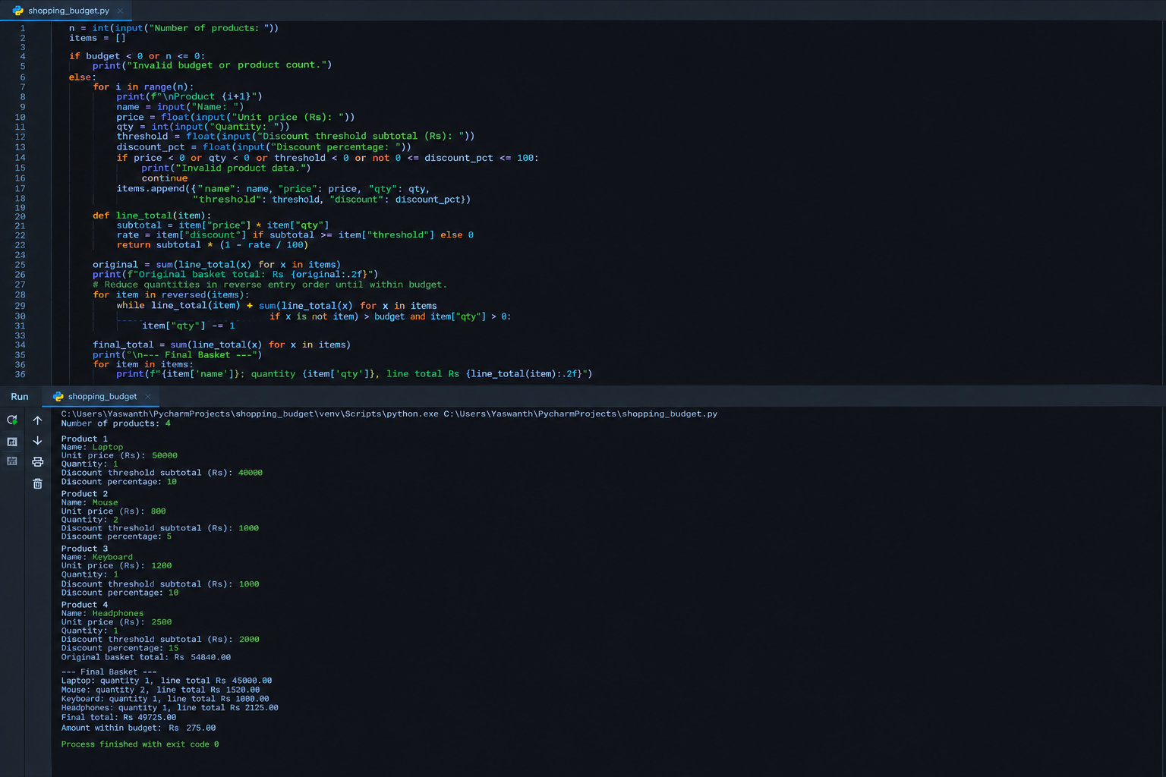

9. Conclusion
The program applies product-level discount rules and uses a clear reduction order to bring the basket within the available budget.

Case Study 20: University Admission Decision Engine

1. Problem Statement
Evaluate applicants using subject eligibility, aggregate marks, course-specific thresholds and tie-breaking rules, then produce a ranked list of eligible applicants.

2. Objectives
- Check subject and aggregate eligibility.
- Apply course-specific cutoffs.
- Rank eligible applicants using aggregate marks and entrance score as tie-breakers.

3. Assumptions
- Applicants provide aggregate marks, required subject marks and entrance score out of 100.
- Course cutoffs are sample rules and should be changed to match official admission policy.
- Ranking uses aggregate descending, then entrance score descending, then name alphabetically.

4. Algorithm
Step 1: Define course-specific aggregate and subject cutoffs.
Step 2: Read applicant details and preferred course.
Step 3: Check all eligibility conditions.
Step 4: Store eligible applicants with ranking fields.
Step 5: Sort and print the ranked list and rejected applicants' reasons.

5. Flowchart
Start → Read and validate input → Process calculations and conditions → Display results → Stop
[Space reserved for hand-drawn or inserted flowchart]

6. Pseudocode
BEGIN
DEFINE course cutoff rules
READ applicants
FOR each applicant DO
check subject and aggregate requirements
IF all conditions met THEN add to eligible list
ELSE record reason
END FOR
SORT eligible by aggregate, entrance score, name
PRINT ranked eligible list and rejection reasons
END

7. Python Source Code
# Case Study 20: University Admission Decision Engine
rules = {
"CSE": {"aggregate": 75, "subject": 70},
"ECE": {"aggregate": 65, "subject": 60},
"MECH": {"aggregate": 55, "subject": 50}
}
n = int(input("Number of applicants: "))
eligible = []
for i in range(n):
print(f"\nApplicant {i+1}")
name = input("Name: ")
course = input("Course (CSE/ECE/MECH): ").upper()
aggregate = float(input("Aggregate percentage: "))
subject = float(input("Required subject percentage: "))
entrance = float(input("Entrance score (0-100): "))
if course not in rules:
print("Rejected: unknown course.")
continue
if not (0 <= aggregate <= 100 and 0 <= subject <= 100
and 0 <= entrance <= 100):
print("Rejected: marks must be between 0 and 100.")
continue
cutoff = rules[course]
reasons = []
if aggregate < cutoff["aggregate"]:
reasons.append(f"aggregate below {cutoff['aggregate']}%")
if subject < cutoff["subject"]:
reasons.append(f"subject marks below {cutoff['subject']}%")
if reasons:
print("Not eligible:", ", ".join(reasons))
else:
eligible.append((aggregate, entrance, name, course))
print("Eligible for ranking.")
eligible.sort(key=lambda x: (-x[0], -x[1], x[2].lower()))
print("\n--- Ranked Eligible Applicants ---")
if not eligible:
print("No eligible applicants.")
else:
for rank, (aggregate, entrance, name, course) in enumerate(eligible, 1):
print(f"{rank}. {name} | {course} | Aggregate: {aggregate:.2f}% "
f"| Entrance: {entrance:.2f}")

8. Test Case and Expected Output
Example: CSE applicant with aggregate 82%, subject marks 78% and entrance score 88 is eligible. A CSE applicant with aggregate 70% is rejected under the sample cutoff.
Output screenshot:
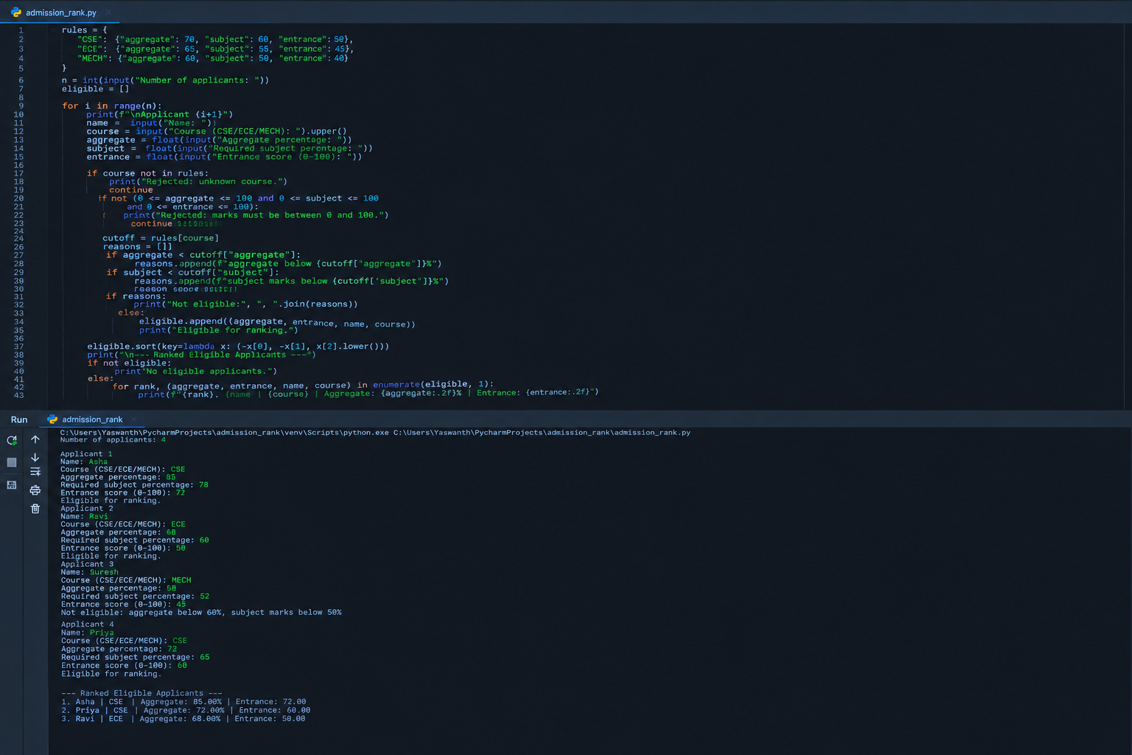

9. Conclusion
The decision engine applies transparent course rules and ranks eligible candidates using stated tie-breakers. The cutoff values are illustrative and must be replaced with official requirements.

Case Study 21: Traffic Violation Penalty Calculator

1. Problem Statement
Calculate fines for multiple traffic violations using vehicle category, offence type and repeat-offence status, and identify disqualification conditions.

2. Objectives
- Apply fine rules based on offence and vehicle type.
- Increase fines for repeat offences.
- Flag offences that cause a disqualification warning.

3. Assumptions
- The fine schedule is illustrative for programming practice and is not legal advice.
- Repeat offences double the base fine.
- Driving without a valid licence and dangerous driving trigger a disqualification warning.

4. Algorithm
Step 1: Define sample fine rules by offence and vehicle category.
Step 2: Read each violation and repeat-offence status.
Step 3: Validate the offence and vehicle category.
Step 4: Calculate base and repeat fine; update total.
Step 5: Display itemized fines and disqualification warnings.

5. Flowchart
Start → Read and validate input → Process calculations and conditions → Display results → Stop
[Space reserved for hand-drawn or inserted flowchart]

6. Pseudocode
BEGIN
DEFINE fine rules and disqualifying offences
READ violation count
FOR each violation DO
READ vehicle, offence, repeat status
IF rule missing THEN report invalid entry
ELSE calculate base fine
IF repeat THEN fine <- fine * 2
add fine to total
IF offence is disqualifying THEN show warning
PRINT violation result
END FOR
PRINT total penalty
END

7. Python Source Code
# Case Study 21: Traffic Violation Penalty Calculator
# Illustrative fines only; verify official local rules for real use.
fine_rules = {
"CAR": {"SPEEDING": 1000, "NO_HELMET": 0,
"NO_LICENCE": 5000, "DANGEROUS_DRIVING": 5000},
"BIKE": {"SPEEDING": 1000, "NO_HELMET": 500,
"NO_LICENCE": 5000, "DANGEROUS_DRIVING": 5000},
"TRUCK": {"SPEEDING": 2000, "NO_HELMET": 0,
"NO_LICENCE": 5000, "DANGEROUS_DRIVING": 10000}
}
disqualifying = {"NO_LICENCE", "DANGEROUS_DRIVING"}
n = int(input("Number of violations: "))
total = 0
warnings = []
for i in range(n):
print(f"\nViolation {i+1}")
vehicle = input("Vehicle (CAR/BIKE/TRUCK): ").upper()
offence = input("Offence (SPEEDING/NO_HELMET/NO_LICENCE/"
"DANGEROUS_DRIVING): ").upper()
repeat = input("Repeat offence? (Y/N): ").upper()
if vehicle not in fine_rules or offence not in fine_rules[vehicle]:
print("Invalid vehicle category or offence.")
continue
if repeat not in ("Y", "N"):
print("Invalid repeat-offence value.")
continue
fine = fine_rules[vehicle][offence]
if repeat == "Y":
fine *= 2
total += fine
print("Penalty: Rs", fine)
if offence in disqualifying:
warning = f"{vehicle}: {offence} - disqualification review required"
warnings.append(warning)
print("WARNING:", warning)
print("\n--- Penalty Summary ---")
print("Total penalty: Rs", total)
if warnings:
print("Disqualification conditions:")
for warning in warnings:
print("-", warning)
else:
print("No disqualification warning under these sample rules.")

8. Test Case and Expected Output
Example: BIKE + NO_HELMET (first offence) = ₹500; CAR + SPEEDING (repeat offence) = ₹2,000. Total = ₹2,500. NO_LICENCE triggers a disqualification review warning.
Output screenshot:
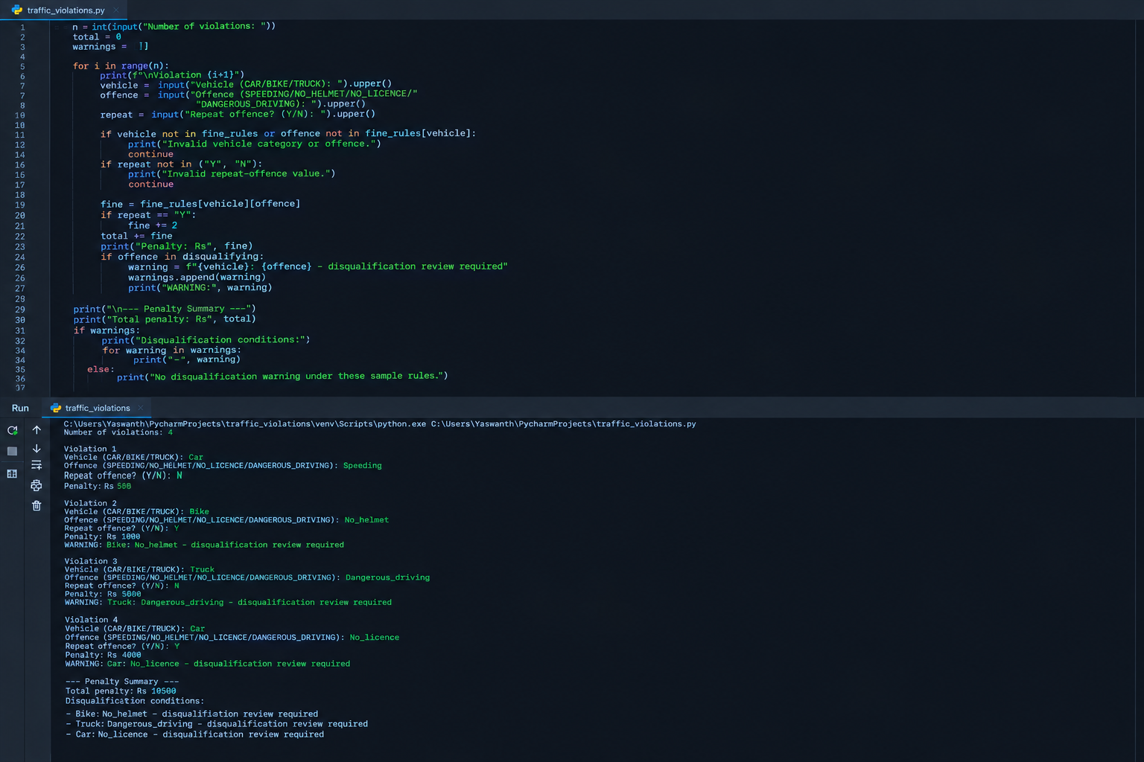

9. Conclusion
The calculator produces an itemized penalty summary and highlights serious offences. Its fine amounts are examples for a coding exercise, not a substitute for current official traffic rules.

